- AND Gate
No. | Input |  | Output |  | Keterangan Logic
No. | A | B | Voltage | LED | Keterangan Logic
1 | 0 | 0 | 0 Volt  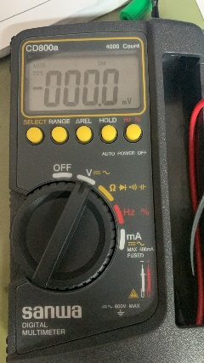 | Mati  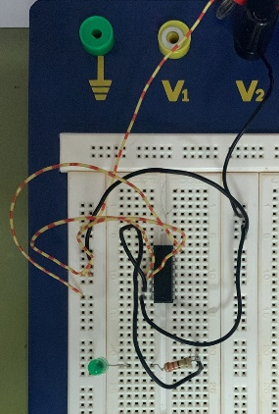 | 0 / Low
2 | 0 | 1 | 0 Volt  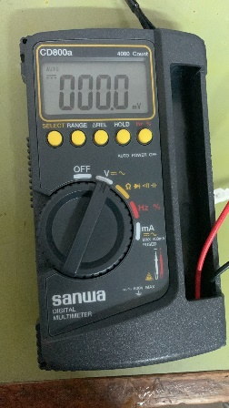 | Mati  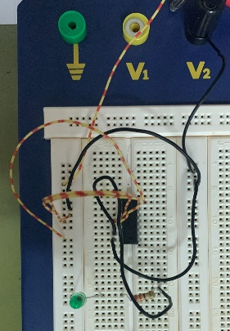 | 0 / Low
3 | 1 | 0 | 0 Volt | Mati  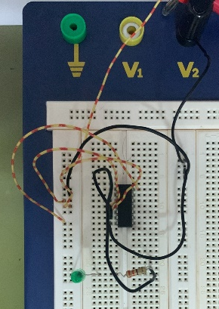 | 0 / Low
4 | 1 | 1 | 1,981 Volt  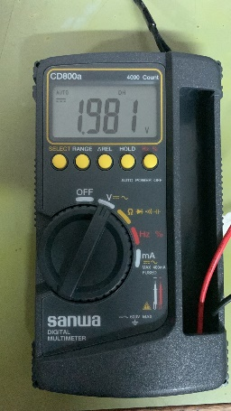 | Menyala  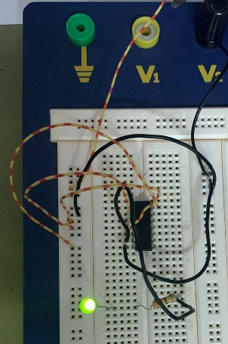 | 1 / Floating State

- OR gate
No. | Input |  | Output |  | Keterangan Logic
No. | A | B | Voltage | LED | Keterangan Logic
1 | 0 | 0 | 0,1 Mili Volt  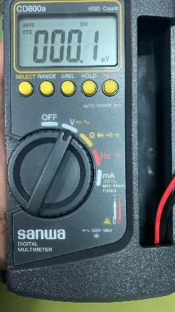 | Mati  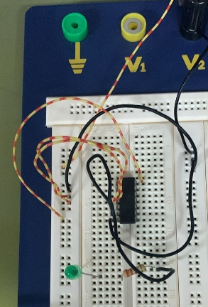 | 0 / Low
2 | 0 | 1 | 1,968 Volt  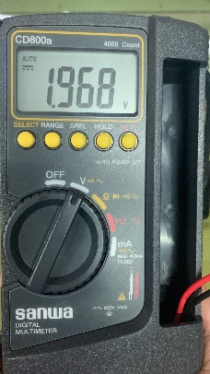 | Menyala  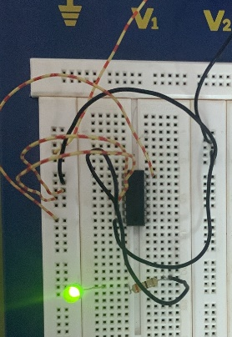 | 1 / Floating State
3 | 1 | 0 | 1,972 Volt  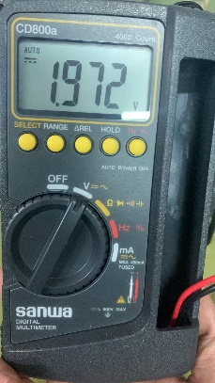 | Menyala  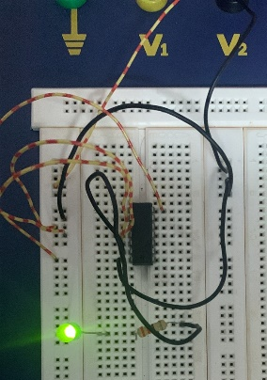 | 1 / Floating State
4 | 1 | 1 | 1,971 Volt  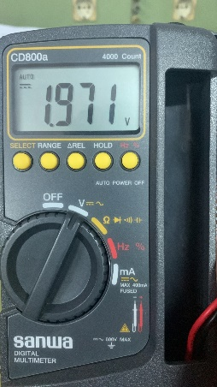 | Menyala  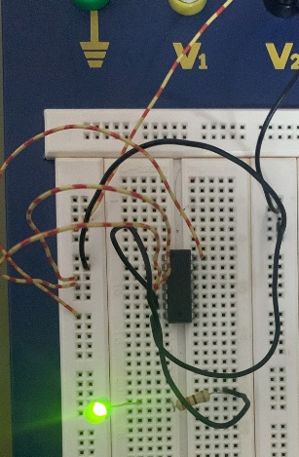 | 1 / Floating State

- NOT Gate
No. | Input | Output |  | Keterangan Logic
No. | A | Voltage | LED | Keterangan Logic
1 | 0 | 1, 848 Volt  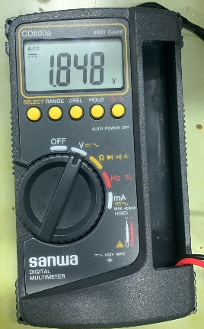 | Menyala  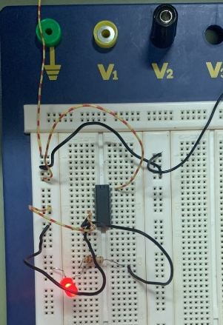 | 1 / Floating State
2 | 1 | 0,156 Volt  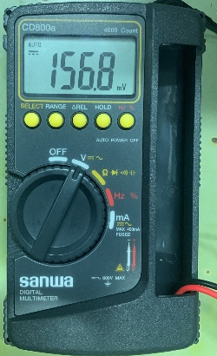 | Mati  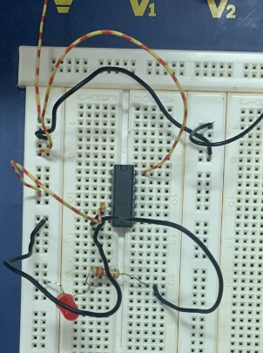 | 0 / Low

- NAND Gate
No. | Input |  | Output |  | Keterangan Logic
No. | A | B | Voltage | LED | Keterangan Logic
1 | 0 | 0 | 1,886 Volt  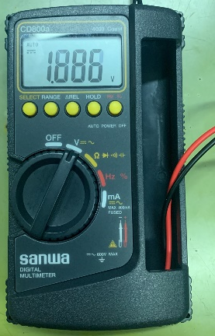 | Menyala  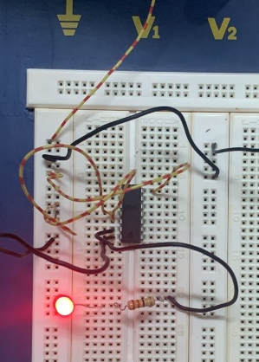 | 1 / Floating State
2 | 0 | 1 | 1,887 Volt  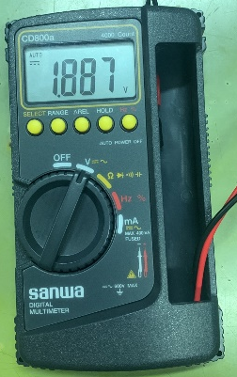 | Menyala  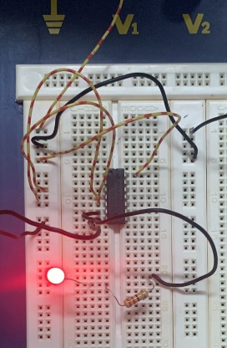 | 1 / Floating State
3 | 1 | 0 | 1,882 Volt  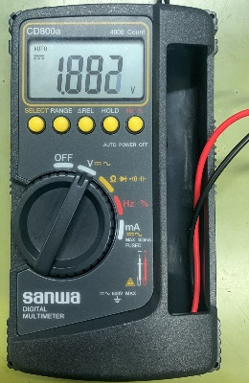 | Menyala  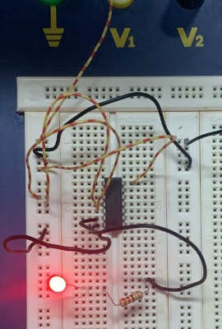 | 1 / Floating State
4 | 1 | 1 | 0 Volt  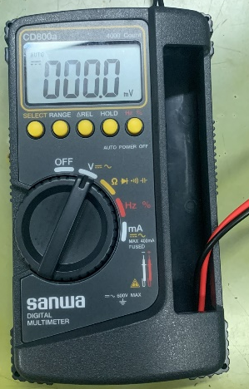 | Mati  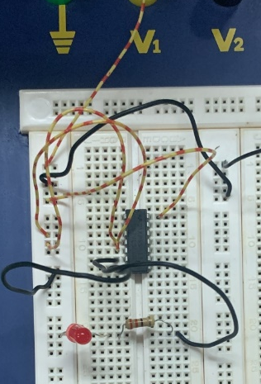 | 0 / Low

- NOR Gate
No. | Input |  | Output |  | Keterangan Logic
No. | A | B | Voltage | LED | Keterangan Logic
1 | 0 | 0 | 1,882 Volt  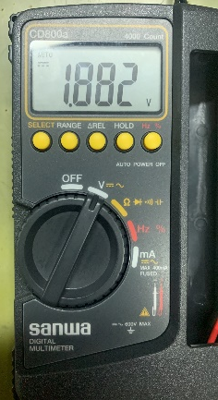 | Menyala  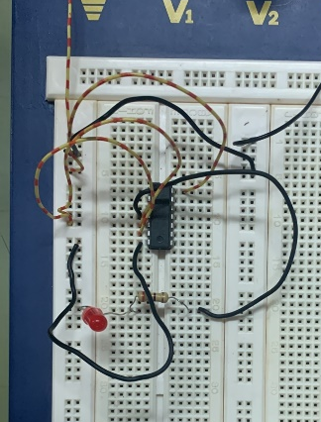 | 1 / Floating State
2 | 0 | 1 | 16,9 Mili Volt  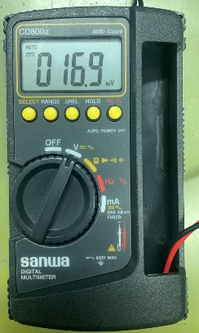 | Mati  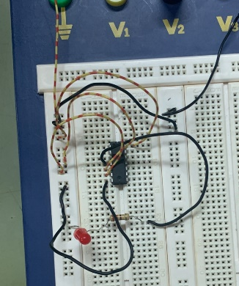 | 0 / Low
3 | 1 | 0 | 2,8 Mili Volt  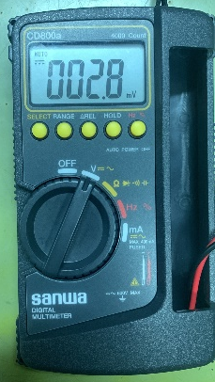 | Mati  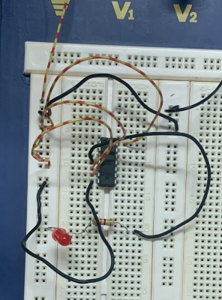 | 0 / Low
4 | 1 | 1 | 16,9 Mili Volt  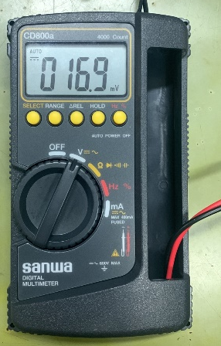 | Mati  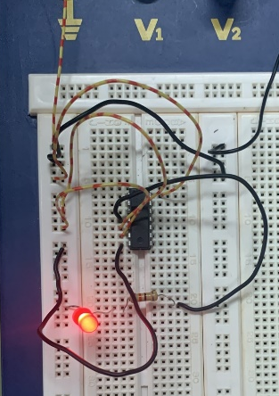 | 0 / Low

- EX – OR Gate
No. | Input |  | Output |  | Keterangan Logic
No. | A | B | Voltage | LED | Keterangan Logic
1 | 0 | 0 | 0,755 Volt  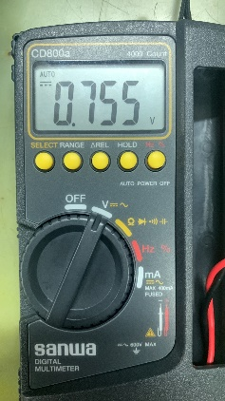 | Mati  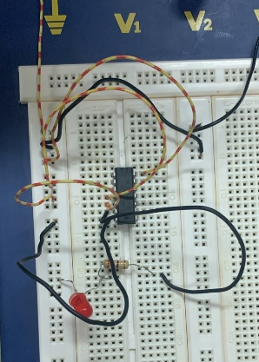 | 0 / Low
2 | 0 | 1 | 1,840 Volt  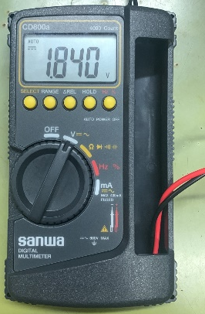 | Menyala  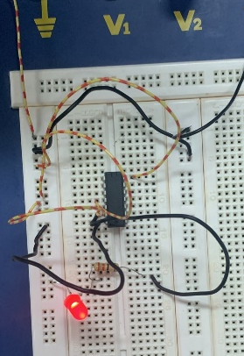 | 1 / Floating State
3 | 1 | 0 | 1,845 Volt  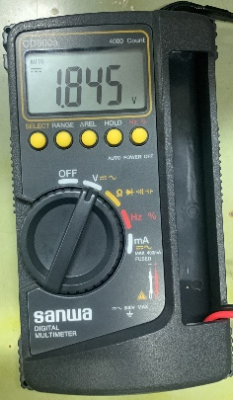 | Menyala  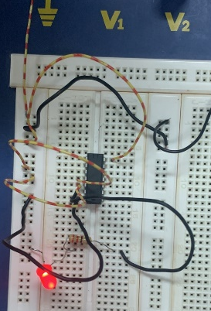 | 1 / Floating State
4 | 1 | 1 | 1,782 Volt  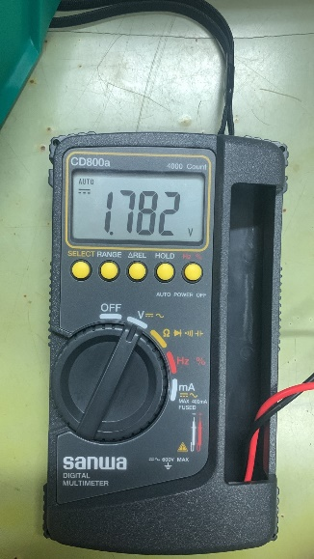 | Mati  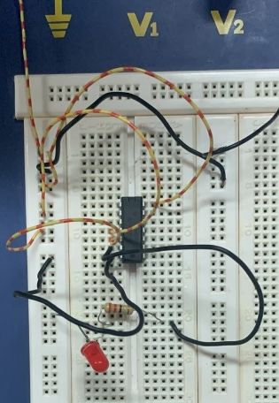 | 0 / Floating State

